1. **Migrate Web Applications - 2 Screenshots**
   * Screenshot of Azure Resource showing the **App Service Plan**.

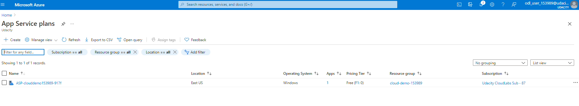

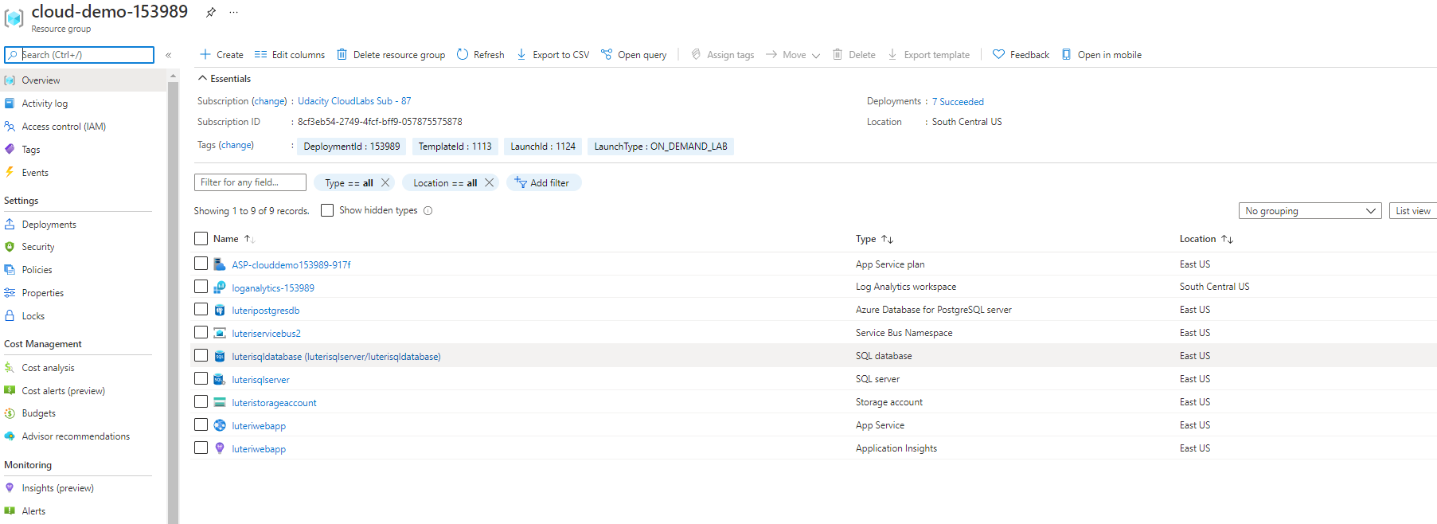

* + Screenshot of the deployed Web App running. The screenshot should be fullscreen showing the URL and application running.

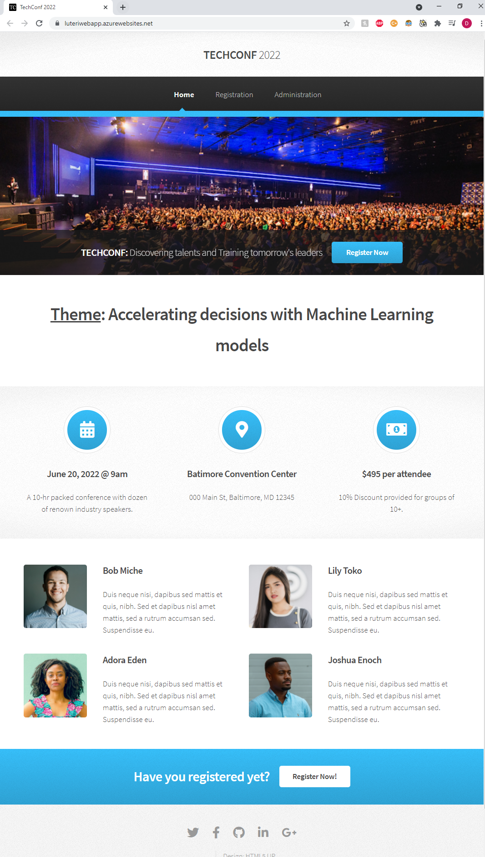

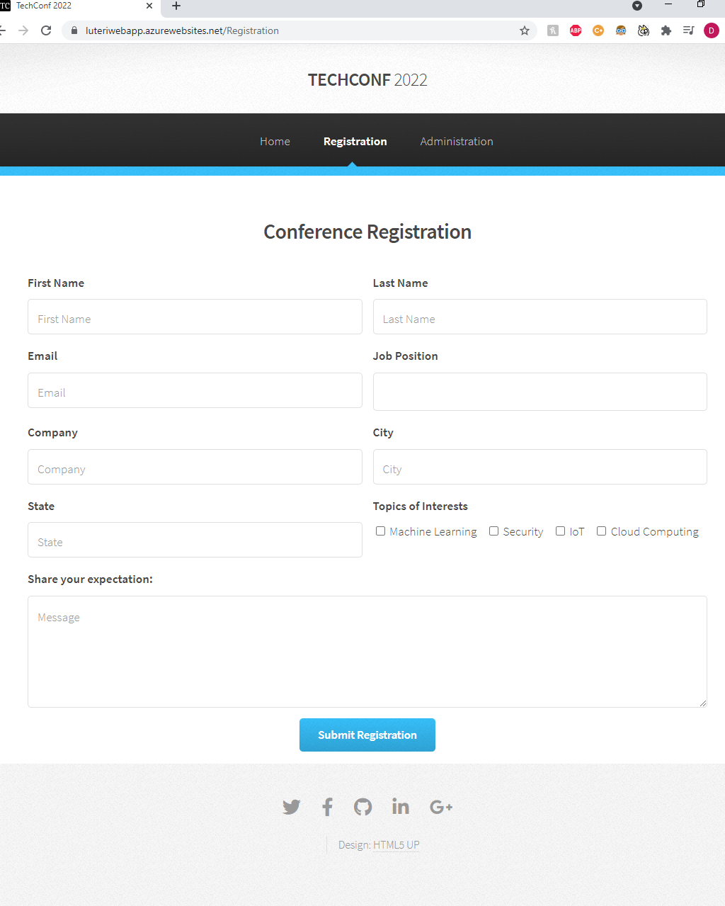

1. **Migrate Database - 2 Screenshots**
   * Screenshot of the Azure Resource showing the **Azure Database for PostgreSQL server**.

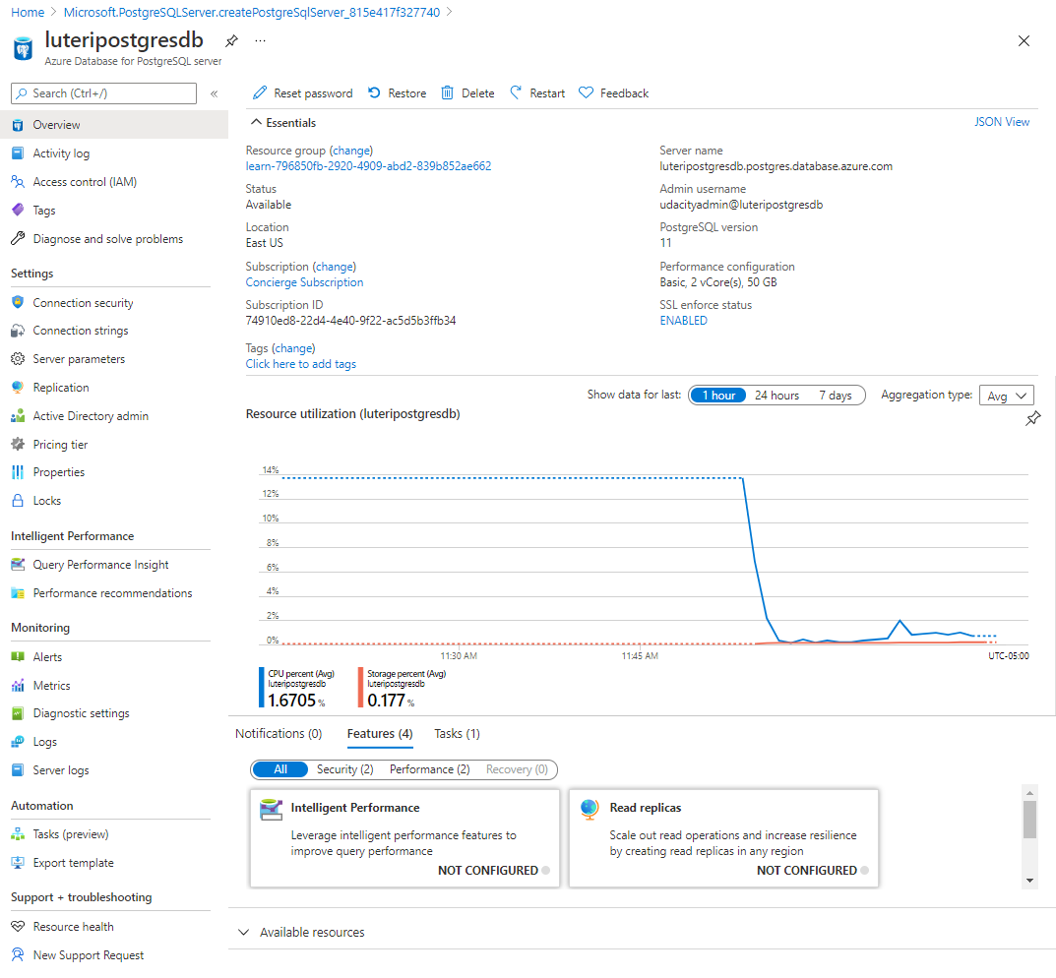

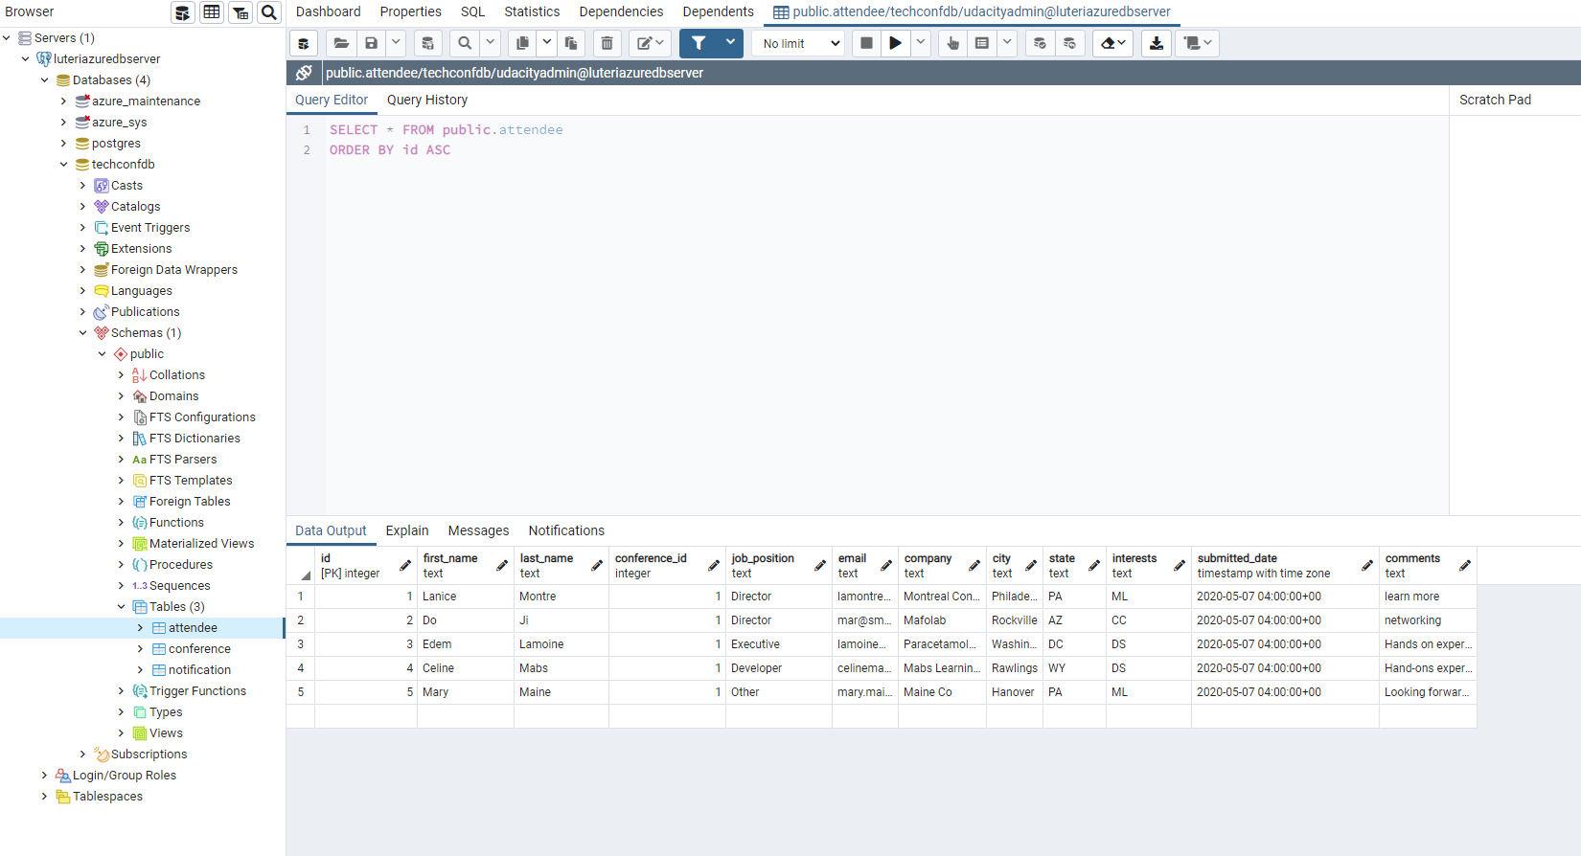

* + Screenshot of the Web App successfully loading the list of **attendees** and **notifications** from the deployed website.

1. **Migrate Background Process - 4 Screenshots**
   * Screenshot of the Azure Function App running in Azure, showing the **function name** and the **function app plan**.
   * Screenshots of the following showing functionality of the deployed site:
     1. Submitting a new notification.
        + Screenshot of filled out **Send Notification** form.
     2. Notification processed after executing the Azure function.
        + Screenshot of the **Email Notifications List** showing the notification status as **Notifications submitted**.
        + Screenshot of the **Email Notifications List** showing the notification status as **Notified X attendees**.

Udacityadmin

Password123!@#